**Build Demand Spectrum**

Case 1 Design Base Earthquake Spectrum





Case 2 Service Level Earthquake Spectrum



$$S_{DS}=0.267, S_{D1}=0.18$$

Case 3 TCU068 100% Spectrum

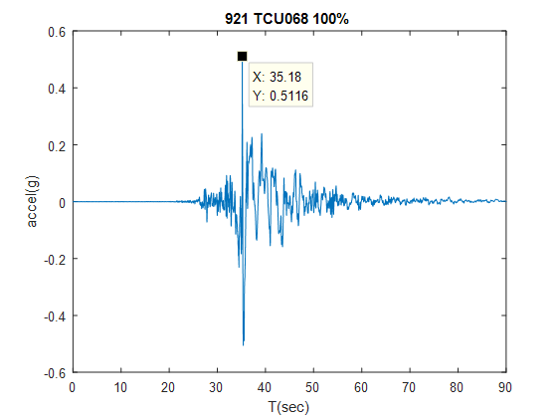

Use Integration Method( Newmark Beta ) to plot SDOF spectrum



Case 4 TCU068 30% Spectrum

First Scale TCU068 to 30% and then plot SDOF spectrum



Build Capacity Spectrum

Use ETABS analysis pushover curve to plot Capacity Spectrum



**Convert to ADRS**

$$S_{d}=\frac{S_{a}}{ω_{n}^{2}}=\frac{T_{n}^{2}}{4π^{2}}S_{a}$$

Case 1 Design Base Earthquake Spectrum



Case 2 Service Level Earthquake Spectrum



Case 3 TCU068 100% Spectrum



Case 4 TCU068 30% Spectrum



Find performance point in Design or TCU068 spectrum is impossible, so we will not discuss in Procedure A, B and C.



